Equations - Worksheet A

1 Solve each of the following equations.

a x + 5 = 18 b x – 9 = 7

________________________________ ________________________________

c 4x = 12 d 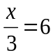

________________________________ ________________________________

2 Solve each of the following equations.

a 2x + 7 = 15 b 7x – 13 = 8

________________________________ ________________________________

________________________________ ________________________________

c 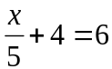 d 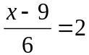

________________________________ ________________________________

________________________________ ________________________________

e 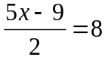 f 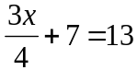

________________________________ ________________________________

________________________________ ________________________________

________________________________ ________________________________

3 Solve each of the following equations.

a 4(x + 3) = 28 b 3(2x + 5) + 2(3x – 7) = 25

________________________________ ________________________________

________________________________ ________________________________

c 9x – 2 = 6x + 13 d 4x – 12 = 8 – x

________________________________ ________________________________

________________________________ ________________________________

________________________________ ________________________________

4 If v = u + at, find:

a u when a = 2, t = 3 and v = 10. b t when a = 4, u = 5 and v = 29.

________________________________ ________________________________

________________________________ ________________________________

5 Express each of the following as an inequality and then show each solution on a
number line.

a x is less than 4 b x is greater than or equal to −2

________________________________ ________________________________

6 Solve each of the following inequalities.

a b

________________________________ ________________________________

________________________________ ________________________________

7 Find the point of intersection (x, y) of y = 2x + 1 and 3x + y = 6 by sketching accurate
graphs on the same set of axes.
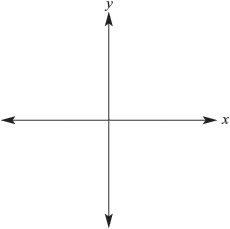
________________________________

________________________________

________________________________

________________________________

________________________________

________________________________

8 Solve the following pairs of simultaneous equations using the elimination method.

a x – y = 17 b 3y + 2x = 8
x + 2y = 5 4y – 2x = 6

________________________________ ________________________________

________________________________ ________________________________

________________________________ ________________________________

________________________________ ________________________________

c 2x + 3y = 19
x – 2y = −8

______________________________________________________________________

______________________________________________________________________

______________________________________________________________________

______________________________________________________________________

______________________________________________________________________

______________________________________________________________________

9 Frank is older than Beth. The sum of their ages is 23 and the difference is 7. Find Frank
and Beth’s ages.

______________________________________________________________________

______________________________________________________________________

______________________________________________________________________

______________________________________________________________________

______________________________________________________________________

______________________________________________________________________

10 Jason buys two highlighters and five pens and pays $16. Eddy buys four highlighters
and three pens and pays $18. Determine the cost of each type of stationery.

______________________________________________________________________

______________________________________________________________________

______________________________________________________________________

______________________________________________________________________

______________________________________________________________________

______________________________________________________________________

